Fawckner: a sketch of a naval officer
Liam Maloney

Born in 1829, William Henry Fawckner was government agent and, in April, 1853, was appointed Second Master ‘to be borne of the books of the [HMS] Phoenix’. He served, however, aboard Breadalbane, the three-masted, barque, merchant ship that was hired by the British Admiralty to accompany the Arctic expedition under Commander Edward Augustus Inglefield.
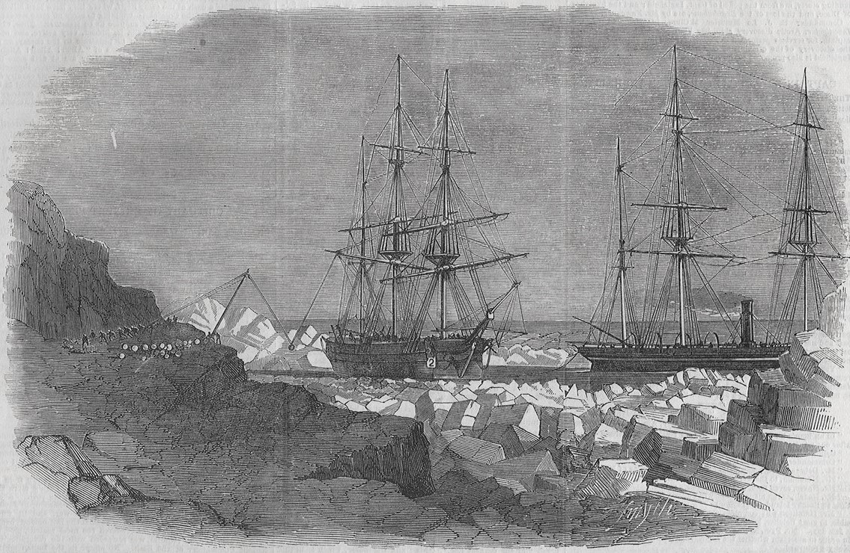
Breadalbane (L) & Phoenix (R) landing stores at Cape Riley, Beechey Island, The Illustrated London News, 22 October, 1853.

The ship was to transport coal, food, clothing, rum and other supplies to Beechey Island. Breadalbane was trapped in the Arctic ice and crushed near Beechey Island in August, 1853. All hands were rescued by HMS Phoenix. Fawckner’s journal is an important source to tell the story as the ship’s logbook is not extant. He wrote about the rapidity of the ice’s destructive work and of the ship’s sinking:
The ship now began to sink fast, and from the time her bowsprit touched the ice, until her mastheads were out of sight, did not occupy above one minute and a half. It was a very sad and unceremonious way of being turned out of our ship. From the time the first nip took her, until her disappearance did not occupy more than fifteen minutes.
He was Second Master of HMS Vengeance at the sea assault of Sebastopol in 1854 during the Crimean War. He was Second master of HMS Duke of Wellington during the bombardment of Sveaborg/Viapori (later named Suomenlinna) in Finland in August, 1855.
During the Second Opium War, Fawckner was present at the Battle of Fatshan Creek against the Qing navy in June, 1857, and then at the storming of Canton in December, 1857. He was Master commanding HMS Hesper during the Battle of Taku Forts (AKA Peiho Forts) in May, 1858. He was also Master of HMS Elk, lent from Hesper, and his gallant conduct was noted to Rear-Admiral Sir Michael Seymour, KCB, Commander-in-Chief East India Station, by Commander Thomas Saumarez. Fawckner is mentioned in Seymour’s dispatches to the Admiralty on 21 May, 1858. Fawckner was made Staff Commander on 20 August, 1867.
He provided evidence and was examined by the court martial established concerning HMS Agincourt in 1871. The ship ran aground on Pearl Rock, near Gibraltar, and nearly sank.
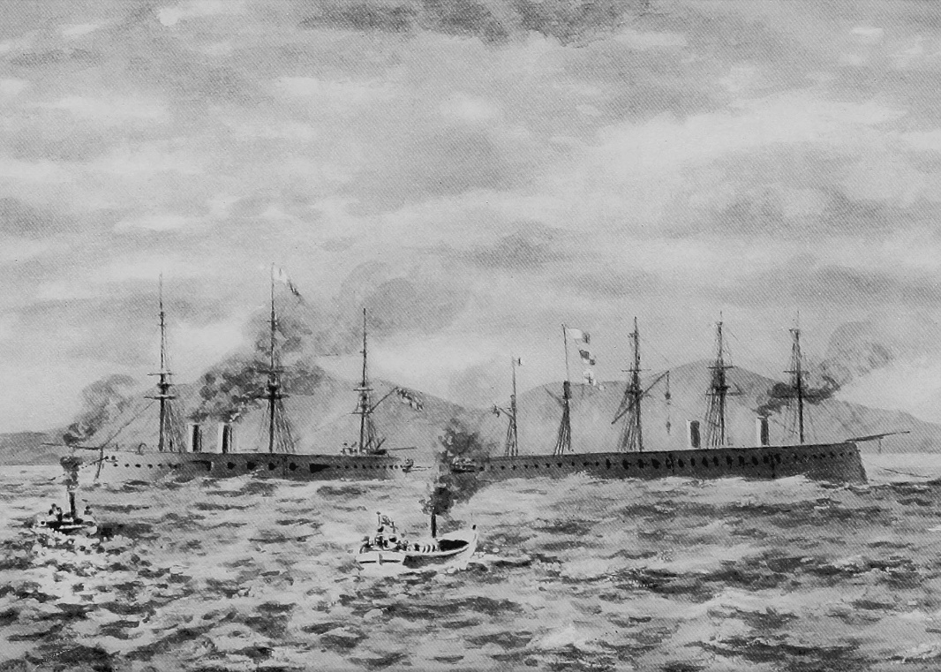
Hercules (L) towing Agincourt (R) off Pearl Rock near Gibraltar, sketch by Commander (later Admiral) Charles Cooper Penrose Fitzgerald of HMS Hercules, frontispiece to his book Memories of the Sea

Fawckner was aboard HMS Hercules, the ship that successfully towed Agincourt off Pearl Rock. Fawckner’s evidence was used, as the newspapers reported, ‘chiefly with a view to elicit the exact extent and degree of inaccuracies in the Bailing directions and charts for entering and leaving Gibraltar Bay, and to receive suggestions for their correction, with a view to ensure future safety’.
Later in life, Fawckner was involved in the Portsmouth branch of the Royal National Lifeboat Institution. He attended annual meetings and quarterly exercises. He was also involved in the Portsmouth Literary and Scientific Society and the Petersfield habitation (what they called their branches) of the Primrose League, a national organisation promoting Conservative party principles.
Fawckner attended a dinner hosted by the Mayor of Portsmouth J. E. Pink at the Town Hall on 23 April, 1904. He expressed his pleasure at being present and said that after he went to the Crimea, he was shipwrecked in the Arctic looking for Franklin. Perhaps he was misremembering the sequence of his various adventures or The Evening News reporter was not listening closely.

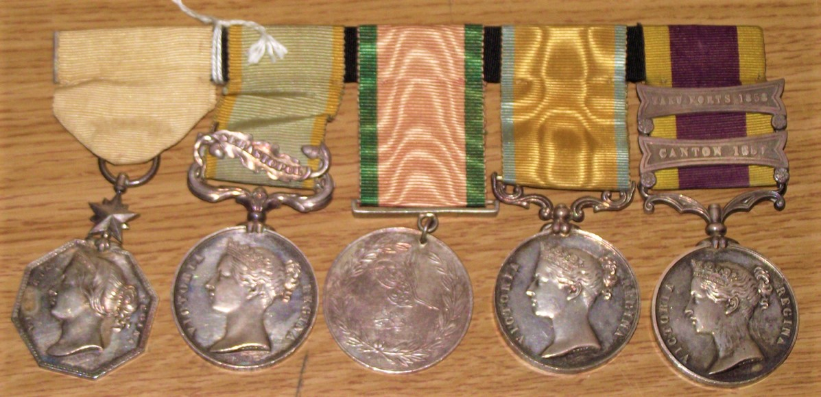
Fawckner’s medals, National Maritime Museum, Greenwich, London

Fawckner retired from a varied naval career on 8 March, 1882, with the rank of Retired Captain and was awarded a Greenwich Hospital pension of £50 a year in 1884. He died at his residence in Wilberforce Road, Southsea, on 27 April, 1914. He was buried in the Highland Road Cemetery, Southsea, following a service at St Paul’s Church, Southsea. He left an estate worth £1,758.
Fawckner’s medal group comprises the Arctic Medal, 1818-1855; the British Crimea medal (Sebastopol clasp), 1854–1856; the Ottoman Crimea medal, 1855; the Baltic Medal, 1854-1855; and the Second China War Medal (Canton and Taku Forts clasps), 1857–1860. He also appears to have been created a Commander of the Royal Norwegian Order of Saint Olav.

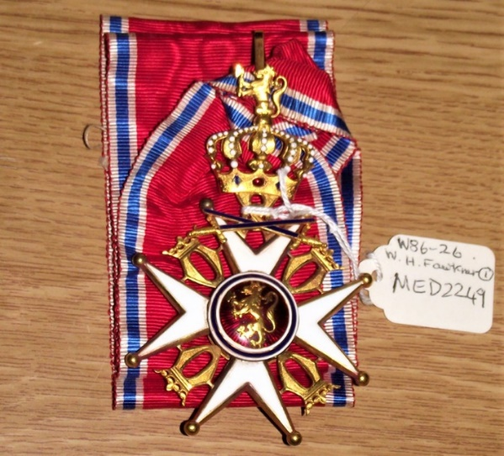
Fawckner’s ribbon & neck badge of a Commander of the Order of St Olaf, National Maritime Museum, Greenwich, London
Sources
Newspapers
The Army and Navy Gazette (London), 12 August, 1871; 9 May, 1914.
The Echo (London), 17 September, 1884.
The Evening News (Portsmouth), 25 April, 1904.
The Evening News and Southern Daily Mail (Portsmouth), 15 May, 1914.
The Hampshire Post and Sussex Observer (Portsmouth), 9 December 1881; 31 March, 1899.
Hampshire Telegraph & Post and Naval Chronicle (Portsmouth), 20 February, 1904; 25 June, 1904; 1 May, 1914.
The Illustrated London News, 22 October. 1853
The London Gazette, 28 July, 1858; 23 August, 1867; 10 March, 1882.
The Petersfield Weekly News and Town and District Advertiser, 29 April, 1891.
The Standard (London), 9 August, 1871.
The Sun (London), 9 April, 1853.

Books
MacInnis, J. The Breadalbane Adventure. Montreal, 1982.
MacInnis, J. The Land that Devours Ships: The Search for the Breadalbane. Toronto, 1985.

Online sources
‘Breadalbane Part 1: Wrecked near the Top of the World’, The Searchers: https://warsearcher.com/2023/06/11/breadalbane-part-1-wrecked-near-the-top-of-the- world/
‘First Arctic Medal’, Royal Museums Greenwich: https://www.rmg.co.uk/collections/objects/rmgc-object-202783.
‘Badge: Order of St Olav, commander’, Royal Museums Greenwich: https://www.rmg.co.uk/collections/objects/rmgc-object-207374.
J. MacInnis, ‘Breadalbane’, The Canadian Encyclopedia: https://www.thecanadianencyclopedia.ca/en/article/breadalbane.

